Lake Fred Water Quality Management & Guidance Plan
2026—2030

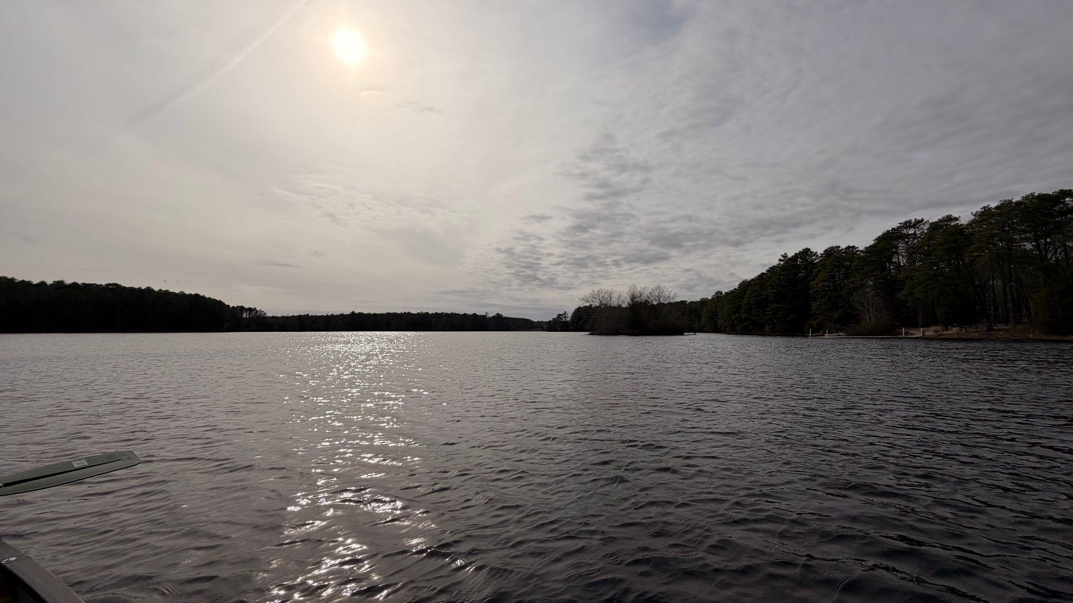
Prepared by: Charles Coriell, Jason Alcott, Sarah Curtis, and Richard Vetter
Course: Project Management, ENSC 5401

Image Taken by Richard Vetter on March 15th, 2026

1. Executive Summary
Lake Fred is a small waterbody located on the campus of Stockton University in Galloway, New Jersey, situated within the Pinelands National Reserve. This Lake Management Plan (LMP) has been developed in response to a Spring 2026 water quality assessment conducted by Stockton University students. The attached water quality field assessment sampled three monitoring stations across Lake Fred: one situated along the northern inlet labeled LFS1, one situated towards the middle of the lake labeled LFS2, and one situated towards the southern outlet labeled LFS3. This plan is structured around the six-phase integrated watershed management cycle (Characterize, Plan, Implement, Monitor, Evaluate, and Adapt), which are consistent with EPA and NJDEP guidance. The March 2026 field assessment revealed that all measured surface water quality parameters were well within NJDEP regulatory thresholds established under N.J.A.C. 7:9B for freshwater bodies and Pineland lakes, with the exception of pH which demonstrated more acidic conditions than are typical of freshwater lakes; however, this acidic quality does not intrinsically go against NJDEP regulatory standards. These results are encouraging and indicate that Lake Fred currently meets acceptable water quality standards.
However, the assessment team identified a significant data gap: nutrient parameters, notably total nitrogen (TN) and total phosphorus (TP), were measured, but the results were compromised by way of improper sample preservation and transportation methods. Therefore, these measurements should be considered estimates rather than fully validated. Additionally, chlorophyll-A, a primary indicator of algal productivity and a key early warning sign of eutrophication, was not sampled during the March cycle. Given the Pinelands setting and the sensitivity of freshwater bodies, this gap represents the principal management concern driving management recommendations. This LMP therefore centers around establishing a robust, regulatory-compliant nutrient and chlorophyll-A monitoring program as the core short-term priority. This plan does not propose major structural interventions currently, but instead establishes the baseline data structure necessary to support evidence-based adaptive management decisions for future cycles.
2. Lake & Watershed Characterization
2.1 Site Description
Lake Fred is a shallow artificial lake located on the Stockton University campus in Galloway Township, Atlantic County, New Jersey. The lake drains through the Mullica River watershed and lies entirely within the outer coastal plain Pinelands region. As such, it is subject to the water quality standards applicable to Pinelands surface waters under N.J.A.C. 7:9B, which generally reflect the naturally nutrient-low acidic characteristics of Pinelands aquatic systems.
The watershed area draining into Lake Fred is dominated by campus land use, including maintained green spaces, impervious surfaces, and limited natural vegetation buffers along portions of the shoreline. The relatively small watershed area and managed campus hydrology limit large-scale agricultural or industrial nutrient loading, though stormwater runoff from impervious surfaces remains a plausible nutrient diffusion pathway.
2.2 Water Quality Baseline
The March 2026 field assessment campaign sampled through stations across the lake during four sampling rounds. Field parameters were measured in-situ using a YSI ProDSS multiparameter Sonde following the NJDEP’s-BFBM Lake Quality Assurance Project Plan 2025 version (QAPP). Sample location and collection were also determined from the same protocol. Grab samples were collected for nutrient analysis, though preservation and transportation procedures were not consistently followed. This may have compromised the nutrient datasets.
Summary of Parameter Compliance Status, Relative to NJDEP Standards.
Parameter | March 2026 Results | NJDEP Threshold Limit | Status/Flag
Dissolved Oxygen (DO) | Meets standards across all stations | ≥ 7.0 mg/L (FW1) | ✅ Compliant
pH | Within range at LFS1, LFS2, LFS3 | 6.5 – 8.5 (Pinelands) | ✅ Compliant
Specific Conductance  (us/cm) | Below benchmark at all stations | Non-regulatory monitoring | ✅ Within range
Turbidity (NTU) | Below threshold | Maximum of 30-day avg of 15 NTU. | ✅ Within range
Temperature (°C) | Consistent with the seasonal baseline | Shall not exceed a daily max of 31°C | ✅ Acceptable
Total Nitrogen (TN) | Estimated only — preservation issue | No codified NJ threshold | ⚠️ Data Quality Flag
Total Phosphorus (TP) | Estimated only — preservation issue | 0.05 mg/L | ⚠️ Data Quality Flag
Chlorophyll-A | Not measured this cycle | No codified NJ threshold | ⚠️ Data Gap

Data Quality Note: Nutrient sample values (TN, NO₃⁻, & TP) from the March 2026 campaign are considered estimated due to improper preservation, and must be treated with caution. A depth recording inconsistency was also flagged at station LFS2 across sampling rounds. An outlier was identified at LFS3 during Round 4. These limitations are acknowledged throughout this plan and are addressed in the monitoring program design.
3. Problem Identification & Goals
3.1 Primary Management Concern
The central management concern of Lake Fred is not a current regulatory exceedance, as there are no data points in the March 2026 dataset that exceed statewide parameter standards. Rather, the primary concern relates to the absence of a validated nutrient baseline dataset. TP and TN are the key drivers of eutrophication in freshwater lakes. Without reliable high quality data, it is impossible to determine whether or not Lake Fred is trending toward increased nutrient loading, elevated algal productivity, or degraded ecological function. The current data gap, therefore, represents a preventative management priority.
Chlorophyll-A is a particularly important co-indicator. Elevated chlorophyll-a concentrations signal algal biomass accumulation, which is typically a direct response to elevated phosphorus in temperate lakes. This early warning indicator is missing from the monitoring program (Berkman & Canova, 2007).
3.2 Management Goals & Objectives
- Establish a validated TN and TP baseline for Lake Fred using high quality, NJDEP-compliant sampling procedures, beginning no later than the next scheduled sampling round.
- Integrate chlorophyll-A as a routine monitoring parameter across all three stations in all future sampling cycles.
- Resolve outstanding data quality issues from the March 2026 assessment, including the LFS2 depth inconsistency and the LFS3 Round 4 outlier, through targeted re-sampling and equipment checks.
- Maintain or improve compliance with all applicable NJDEP surface water quality standards under N.J.A.C. 7:9B throughout the planned period.
- Develop internal data quality objectives for all parameters. Establish acceptable precision and accuracy thresholds for the laboratory and field programs and activities.
- Produce an annual data summary report for distribution to stakeholders, including Stockton University environmental clubs, Pinelands Preservation Alliance group, and, where appropriate, the NJDEP.
4. Action Plan — Nutrient Monitoring Program
4.1 Overview
The action plan for Lake Fred focuses on addressing the primary issue identified in this assessment, which is a lack of validated nutrient and chlorophyll-a data. The first step should be implementing a standardized protocol for sampling nutrient parameters on Lake Fred. This will act as an early indicator for potential eutrophication incidents. Some of the data inconsistencies presented in this report will be remedied through creating a standardized protocol as well. A data quality objectives list will be developed as well, to define the acceptable levels of accuracy and precision in the future. Overall, this plan prioritizes the building of a reliable and defensible dataset before considering any structural management interventions.
4.2 Management Goals & Objectives

Parameter | Frequency | Method | Priority Rationale
Total Phosphorus (TP) | Quarterly | Grab sample, proper preservation, lab analysis | Core nutrient — primary eutrophication driver
Total Nitrogen (TN) | Quarterly | Grab sample, proper preservation, lab analysis | Core nutrients paired with TP for N:P ratio
Chlorophyll-a | Quarterly | Grab sample, proper preservation, lab analysis | Algal biomass proxy; eutrophication early warning
DO, pH, Temp, Conductance | Quarterly (continuous if possible) | YSI Pro DSS in-situ profile | Regulatory compliance; ongoing baseline
Turbidity | Quarterly | YSI Pro DSS in-situ | Optical indicator of biological activity
Depth / Bathymetry | Annually | Transect profiling at all 3 stations | Resolve various depth inconsistencies from Rounds 1–4

5. Monitoring & Evaluation
The monitoring and evaluation process for Lake Fred will focus on ensuring that the data collected moving forward is both reliable and useful for identifying potential water quality trends. Sampling will be conducted consistently across the established stations, with particular emphasis on nutrient parameters and chlorophyll-a as indicators of potential eutrophication. All collected data will be evaluated against established standards as the data quality objectives developed in the action plan. This will ensure that accuracy and precision are maintained. Over time, this monitoring will lead to the development of a validated baseline, leading to the identification of any changes or emerging issues within the lake system.
Overall, this approach emphasizes consistency and data quality, allowing for the performance of informed decision-making before larger-scale management actions are considered.
6. Assessment & Adaptive Cycle
In response to the data evaluation from the nutrient monitoring program established in this guidance plan, a team will assess the conditions of Lake Fred for a potential management intervention and response action plan. It is important to note that the standard threshold limits listed below are for management purposes only and are not solidified as fixed regulatory standards by the NJDEP, due to changing environmental conditions over time. Also, these are based on general freshwater lake management literature and Pinelands aquatic ecology guidelines.
- Total Phosphorus > 0.05 mg/L in-lake: Indicates a potential shift towards mesotrophic conditions. If detected, increase sampling frequency and investigate potential source pathways.
- Chlorophyll-a > 20 μg/L in-lake: Suggests moderate algal biomass. If detected, conduct visual algal bloom surveys and consider performing a nutrient source assessment.
- Any single-parameter NJDEP standard exceedance in-lake: If detected, initiate immediate re-sampling at affected station, notify project advisor, and document in quarterly report.
- Sustained declining DO trend, defined as two consecutive rounds below 7.0 mg/L: If detected at any station, investigate potential biological oxygen demand sources. Consider hydrological or sediment analysis.
At the conclusion of each annual monitoring cycle, the assessment team shall conduct a structured data review which should address the following: (1) whether or not all parameters remain within compliance; (2) whether or not nutrient trends are stable, improving, or declining; (3) whether or not the monitoring design and quality maintenance program are functioning as intended; and (4) whether or not any management responses are warranted, based on trigger thresholds. The outcomes of this review shall be documented in the annual summary report and used to update the monitoring program for the following cycle. The plan shall undergo a formal revision every three years, incorporating all accumulated monitoring data, any changes to NJDEP regulatory standards, and updated stakeholder input. Interim adaptive adjustments such as changes to sampling frequency, station locations, or analytical parameters may be made outside the monitoring cycle by team consensus and within documentation.
7. Stakeholder Involvement & Engagement
The primary stakeholders for the Lake Fred LMP include the Stockton Water Watch Club, S.A.V.E., the Environmental Science Department, the Pinelines Preservation Alliance advocacy group, Galloway Township public works sector, and regulatory agencies like the Pinelands Commission. Additional parties may include the NJDEP, if appropriate, and other regional watershed organizations. The assessment team shall produce an annual data summary report to be distributed to all primary stakeholders by the end of each monitoring year. Stakeholder meetings shall be scheduled at a minimum of once per school semester. Wherever feasible, summarized water quality data shall be made available to the campus community through direct communication with Stockton Water Watch.
To ensure stakeholder engagement and support for this management plan, it is recommended that the Stockton community creates a Lake Fred Watershed Association to act as a research and funding hub for future projects and data collection from Lake Fred and the surrounding region. Creation of a watershed association will benefit the campus through hands-on research opportunities and long-term data collection to obtain multi-year datasets on water quality, hydrology, and ecosystem health within the Pinelands region. In addition, this student-run club could potentially build a lasting culture of environmental stewardship and community engagement around the Pinelands region, inspiring other groups to get involved in future environmental monitoring efforts.

Literature Cited
Berkman, J.A.H., and Canova, M.G. (2007). Chapter 7.4, Algal biomass indicators: U.S. Geological Survey Techniques of Water-Resources Investigations, book 9, chap 7.4, https://doi.org/10.3133/twri09A7.4.
New Jersey Department of Environmental Protection. BFBM Lake Monitoring Network, Quality Assurance Project Plan. May 2025. Quality Assurance Project Plan
New Jersey Department of Environmental Protection. N.J.A.C. 7:9B — Surface Water Quality Standards. Trenton, NJ: NJDEP.
Pinelands Commission. Comprehensive Management Plan for the Pinelands National Reserve. New Lisbon, NJ: New Jersey Pinelands Commission.
U.S. Environmental Protection Agency. Handbook for Developing Watershed Plans to Restore and Protect Our Waters. EPA 841-B-08-002. Washington, DC: USEPA, 2008.Handbook for Developing Watershed Plans to Restore and Protect Our Waters, March 2008

