Lake Fred Preliminary Water Quality Assessment Report
Preliminary Baseline Water Quality Report
Stockton University | Galloway, N.J. | April, 2026
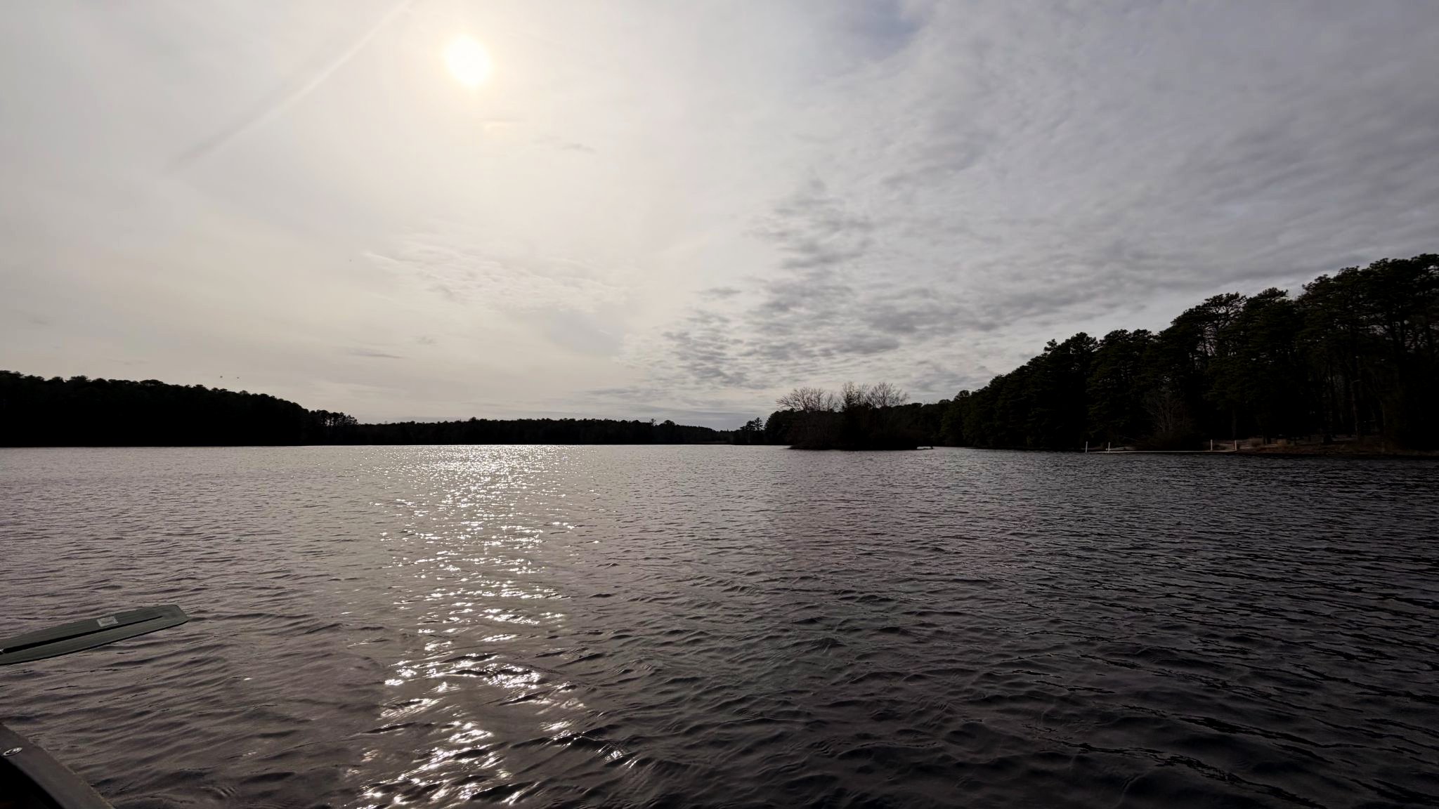

Prepared by: Charles Corielle, Jason Alcott, Sarah Curtis, and Richard vetter
Course: Project Management, ENSC 5401
Project Background
Lake Fred is a central feature of Stockton University, acting as both a key amenity and a prominent element of marketing. For education opportunities, Lake Fred is a valuable resource for hands-on learning to support coursework, research, and ecological studies across a variety of academic disciplines. Lake Fred supports fishing, boating, and other recreational activities for students, staff, and the public alike. The beauty of Lake Fred is also a key point of pride for Stockton University.
Despite its ecological, economic, and even aesthetic importance of Lake Fred, no comprehensive initiatives in the past decade had assessed its water quality. While there have been some student-led initiatives which performed baseline water sampling activities, these initiatives lack data for complex water quality parameter monitoring, including data regarding total nutrient levels or algal bloom potential, the latter of which is observed by measuring phycocyanin and chlorophyll-a in the waterbody (NJCOLA - Lake Water Quality Testing, 2020).
This assessment report will help fill this gap by providing insight into specific baseline water quality parameters, nutrient level monitoring, and the potential for harmful algal activity. The primary objectives are to provide collected water quality data, present the subsequent analysis performed, and inform long-term water quality monitoring and management. This will ultimately sustain the ecological integrity and recreational value of Lake Fred.
Site Map of Lake Fred
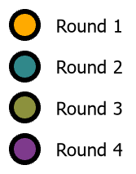
This aerial map shows the size, shape, and location of Lake Fred in relation to the Stockton University Campus and some adjacent water bodies, such as Lake Naomi and Norma Mill Stream. Sampling locations have been highlighted and color-coded. Precise coordinates of sampling locations are documented in subsequent pages.
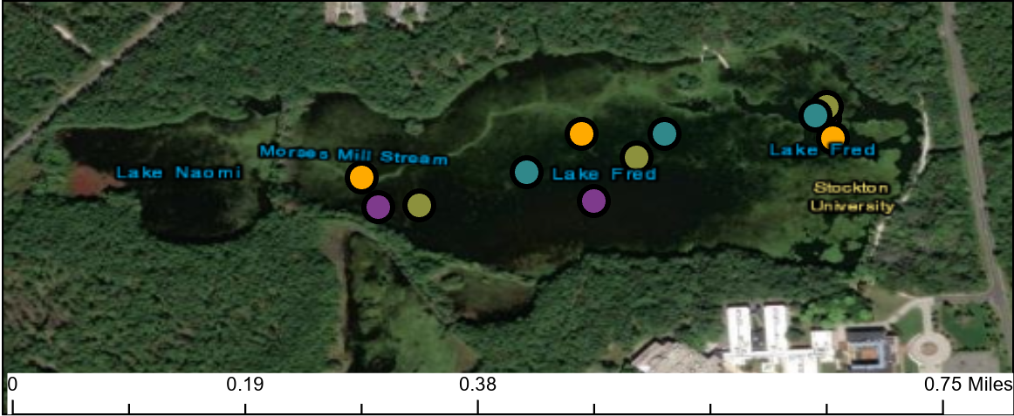

Methodology
Site selection and sample collection methodology was based on professional environmental collection standards published in the NJDEP Bureau of Freshwater and Biological Monitoring 2025 Lakes QAPP. Details of this methodology are quoted directly from the handbook and presented in Appendix B: NJDEP-BFBM Lakes Monitoring Network (2025) QAPP Rules.
In this study, three approximately equidistant monitoring stations were chosen to capture spatial variation across the lake. These stations were assigned the identification codes LFS1, LFS2, and LFS3, where the acronym “LFS” stands for “Lake Fred Station”. Four rounds of sampling were conducted at each station, and water quality parameter measurements were taken at multiple depths per station. All water samples were collected using a horizontal Van Dorn sampler. Samples for rounds 1 & 2 were collected on Mar. 15th, 2026. Samples for rounds 3 & 4 were collected on Mar. 21st, 2026. Twelve samples were collected in total.
General water quality parameters for each sample were collected on-site using a YIS ProDSS water quality probe, capable of measuring water temperature, dissolved oxygen (DO), percent DO saturation, specific conductivity, pH, salinity, turbidity, and chlorophyll-a. Turbidity (NTU units) measurements were collected by a HACH 2100Q Turbidimeter and Fluorescence (RFU units) was captured using a Phycocyanin meter. Water clarity and transparency were measured in terms of light penetration into the water column via a Secchi disk. Secchi disk readings are recorded by taking the centimeter depth at which the disk becomes no longer visible. Nutrient parameter data was tested by a local laboratory, which analyzed total nitrogen (TN), nitrate (NO₃⁻), and total phosphorous (TP) levels for each sample, associated with each sample and round.

Water Quality Parameter Data
Table 1. Sampling Station Plan Summary.
Station ID | Approximate Coordinates | Dates Sampled | Sampling Rounds | Estimated Sample Depths
LFS1 | -39.4964°N  -74.5303°W | 03/15/2026  03/21/2026 | Rounds 1–4 | 0.135—1.2 m
LFS2 | -39.4955°N  -74.5330°W | 03/15/2026  03/21/2026 | Rounds 1–4 | 0.135—1.2 m
LFS3 | -39.4957°N  -74.5353°W | 03/15/2026  03/21/2026 | Rounds 1–4 | 0.135—1.2 m
Table 1 shows a summary of the planned sampling station information. The project team initially planned to collect samples across several different days. However, due to various constraints, it was determined that the project team would perform four sampling rounds over the course of just two days. Table 2 shows the actual sampling information.
Table 2. Total Depth Measurements & Readings.
Station | Round | Total Depth of Lake (m) | Expected  Depths (m) | Actual Depth  Recorded (m)
LFS1 | 1 | 0.95 | 0.1, 0.45, 0.45 | 0.845, 0.527, 0.481
LFS1 | 2 | 1.0 | 0.1, 0.5 (3) | 1.03, 0.54, 0.51
LFS1 | 3 | 0.85 | 0.1, 0.425 (2), 0.35 | 0.430, 0.132, 0.453
LFS1 | 4 | 0.9 | 0.1, 0.45 (2), 0.4 | 0.47, 0.44, 0.1
LFS2 | 1 | 1.12 | 0.1, 0.62 (3) | 0.695, 0.620, 0.473, 0.418
LFS2 | 2 | 1.25 | 0.1, 0.75 (2), 0.625 | 0.64, 0.876, 0.644
LFS2 | 3 | 0.9 | 0.1, 0.45 (2), 0.4 | 0.258, 0.107, 0.120
LFS2 | 4 | 0.83 | 0.1, 0.415 (2), 0.33 | 0.376, 0.37, 0.128
LFS3 | 1 | 0.87 | 0.1, 0.435 (2), 0.37 | 0.395, 0.37, 0.42
LFS3 | 2 | 0.7 | 0.1, 0.35 (2), 0.2 | 0.342, 0.65, 0.532
LFS3 | 3 | 0.5 | 0.1 | 0.26, 0.1
LFS3 | 4 | 0.5 | 0.1 | 0.315, 0.1 (2), 0.136
Table 2 shows the total depth measurements and readings recorded during sampling. All depth readings are measured in meters below the surface of the lake. For the expected depths of LFS3 rounds 3 & 4, the lake was too shallow to collect further readings. To learn more about how the project team recorded depth measurements readings, see Appendix B.
Combined, Table 3 reports the water quality parameters for rounds 1 & 2, which occurred on Mar. 15th, 2026. These water quality parameters were temperature, pressure, DO, percent DO saturation, specific conductivity, salinity, pH, turbidity, and fluorescence.
Table 3a. Water Quality Physical Data, Rounds 1 & 2. Parameters: Temperature, Pressure, & Dissolved Oxygen.
Round | Station | Time (PM) | Temp (°C) | Pressure (mmHg) | DO SAT% | Dissolved Oxygen (mg/L)
1 | LFS1 | 2:48:33 | 9.9 | 769.2 | 95.4 | 10.92
1 | LFS1 | 2:49:33 | 10 | 769.2 | 69.3 | 7.92
1 | LFS1 | 2:50:29 | 9.9 | 769.2 | 81.6 | 9.34
1 | LFS1 | 3:04:39 | 9.9 | 768.9 | 95.6 | 10.94
1 | LFS2 | 3:07:52 | 9.9 | 769.0 | 60.2 | 6.88
1 | LFS2 | 3:09:01 | 9.9 | 769.0 | 77.3 | 8.84
1 | LFS2 | 3:22:59 | 10.0 | 768.9 | 90.5 | 10.34
1 | LFS2 | 3:24:34 | 10.0 | 768.8 | 62.1 | 7.08
1 | LFS3 | 3:27:12 | 10.1 | 768.8 | 82.5 | 9.39
1 | LFS3 | 3:27:34 | 10.1 | 768.7 | 88.8 | 10.12
1 | LFS3 | 3:42:19 | 10.1 | 768.7 | 94.8 | 10.8
2 | LFS1 | 3:43:04 | 10.1 | 768.8 | 88.4 | 10.07
2 | LFS1 | 3:43:45 | 10.1 | 768.7 | 92.8 | 10.58
2 | LFS1 | 3:51:43 | 10.0 | 768.5 | 94.1 | 10.74
2 | LFS2 | 3:53:05 | 10.0 | 768.6 | 59.1 | 6.75
2 | LFS2 | 3:54:16 | 10.0 | 768.5 | 81 | 9.25
2 | LFS2 | 3:59:19 | 10.3 | 768.4 | 100.6 | 11.38
2 | LFS3 | 3:59:51 | 10.3 | 768.4 | 48.6 | 5.5
2 | LFS3 | 4:00:25 | 10.3 | 768.5 | 89.7 | 10.16
Table 3a shows water temperature, pressure, DO, and percent DO saturation for rounds 1 & 2. Water temperature varied from 9.0°C to 11.0°C. Pressure remained largely consistent, ranging from 768.4 mmHg to 769.2 mmHg. DO varied significantly across sample readings. The lowest DO reading was 5.5 mg/L, representing 48.6% saturation, while the highest Do reading was 11.38 mg/L, representing 100.6% saturation.
Table 3b. Water Quality Physical Data, Rounds 1 & 2. Parameters: Special conductivity, Salinity, & pH.
Round | Station | Time (PM) | Specific Conductivity  (μs/cm) | Salinity (ppt) | pH
1 | LFS1 | 2:48:33 | 97.1 | 0.05 | 5.72
1 | LFS1 | 2:49:33 | 114.1 | 0.05 | 5.71
1 | LFS1 | 2:50:29 | 98.4 | 0.05 | 5.87
1 | LFS1 | 3:04:39 | 98 | 0.05 | 5.89
1 | LFS2 | 3:07:52 | 98.2 | 0.05 | 5.85
1 | LFS2 | 3:09:01 | 96.6 | 0.05 | 5.59
1 | LFS2 | 3:22:59 | 96.5 | 0.05 | 5.56
1 | LFS2 | 3:24:34 | 108.5 | 0.05 | 5.56
1 | LFS3 | 3:27:12 | 95.8 | 0.04 | 5.42
1 | LFS3 | 3:27:34 | 94.7 | 0.04 | 5.54
1 | LFS3 | 3:42:19 | 97.5 | 0.05 | 5.68
2 | LFS1 | 3:43:04 | 97.5 | 0.05 | 5.71
2 | LFS1 | 3:43:45 | 97.3 | 0.05 | 5.68
2 | LFS1 | 3:51:43 | 99.8 | 0.05 | 5.66
2 | LFS2 | 3:53:05 | 101.5 | 0.05 | 5.82
2 | LFS2 | 3:54:16 | 100 | 0.05 | 5.74
2 | LFS2 | 3:59:19 | 94.7 | 0.04 | 5.62
2 | LFS3 | 3:59:51 | 96.5 | 0.05 | 5.77
2 | LFS3 | 4:00:25 | 95.4 | 0.05 | 5.7
Table 3b shows specific conductivity, salinity, and pH for rounds 1 & 2. Specific conductivity shows slight variation, from 94 μs/cm to 115 μs/cm. Salinity stayed consistent, ranging only from 0.04 ppt to 0.05 ppt. Water pH was largely acidic, ranging from 5.40 to 5.89.
Table 3c. Water Quality Physical Data, Rounds 1 & 2. Parameters: Turbidity & Fluorescence.
Round | Station | Turbidity (NTU) | Flurosence (RFU)
1 | LFS1 | 2.79 | 7
1 | LFS2 | 7.51 | 10
1 | LFS3 | 7.40 | 15
2 | LFS1 | 2.97 | 8
2 | LFS2 | 2.77 | 12
2 | LFS3 | 5.57 | 3
Table 3c shows turbidity and fluorescence readings for rounds 1 & 2. Turbidity and fluorescence readings were recorded on the shoreline, and thus are not attached to the associated depths sampling times. The highest turbidity recorded was 7.51 NTU, recorded during round 1, and the lowest turbidity recorded was 2.77 NTU, recorded during round 2; both were recorded at LFS2. The highest fluorescence reading was 15 RFU, recorded during round 1, and the lowest fluorescence reading was 3 RFU, recorded during round 2; both were recorded at LFS3.
Table 4. Secchi Disk Depth Readings.
Station | Round | Secchi Disk Depth (m)
LFS1 | 1 | 0.95
LFS1 | 2 | 0.8
LFS1 | 3 | 0.7
LFS1 | 4 | 0.75
LFS2 | 1 | 1.1
LFS2 | 2 | 1.2
LFS2 | 3 | 1.0
LFS2 | 4 | 1.2
LFS3 | 1 | 0.75
LFS3 | 2 | 0.75
LFS3 | 3 | bottom
LFS3 | 4 | bottom
Table 4 shows the Secchi disk readings for each station and round. To learn more about how the project team performed secchi disk readings, see Appendix B.
Combined, Table 5 reports the water quality parameters for rounds 3 & 4, which occurred on March 21st, 2026. Parameters were the same as in Table 4.
Table 5a. Water Quality Physical Data, Rounds 3 & 4. Parameters: Parameters: Temperature, Pressure, & Dissolved Oxygen.
Round | Station | Time (PM) | Temp (°C) | Pressure (mmHg) | DO SAT% | Dissolved Oxygen (mg/L)
3 | LFS1 | 1:12:42 | 12.2 | 758.1 | 79.1 | 8.47
3 | LFS1 | 1:15:33 | 12.2 | 758.0 | 95.2 | 10.18
3 | LFS1 | 1:24:57 | 12.0 | 758.2 | 86.7 | 9.31
3 | LFS2 | 1:39:42 | 13.1 | 758.1 | 84.8 | 8.88
3 | LFS2 | 1:39:51 | 13.1 | 758.1 | 87.0 | 9.11
3 | LFS2 | 1:41:12 | 13.1 | 758.1 | 95.6 | 10.02
3 | LFS3 | 1:58:52 | 13.9 | 757.8 | 81.2 | 8.36
3 | LFS3 | 1:59:08 | 13.9 | 757.8 | 87.2 | 8.98
4 | LFS1 | 2:16:37 | 12.5 | 757.9 | 91.7 | 9.74
4 | LFS1 | 2:16:43 | 12.4 | 757.9 | 92.1 | 9.80
4 | LFS1 | 2:17:20 | 12.8 | 757.9 | 95.1 | 10.04
4 | LSF2 | 2:31:43 | 13.8 | 757.8 | 86.1 | 8.89
4 | LSF2 | 2:31:47 | 13.8 | 757.8 | 87.2 | 9.00
4 | LSF2 | 2:32:29 | 13.7 | 757.6 | 95.6 | 9.87
4 | LFS3 | 2:44:00 | 13.7 | 757.8 | 47.6 | 4.92
4 | LFS3 | 2:45:12 | 14.2 | 757.8 | 90.0 | 9.2
4 | LFS3 | 2:45:44 | 13.9 | 757.8 | 95.2 | 9.8
4 | LFS3 | 2:55:38 | 18.1 | 757.9 | 99.3 | 9.36
Table 5a shows water temperature, pressure, DO, and percent DO saturation. Water temperature varied from 12.0°C to 18.1°C. Pressure remained largely consistent, ranging from 757.8 mmHg to 758.2 mmHg. DO once again varied significantly across sample readings. The lowest DO reading was 4.92 mg/L, representing 47.6% saturation, while the highest DO reading was 9.36 mg/L, representing 99.3% saturation.
Table 5b. Water Quality Physical Data, Rounds 3 & 4. Parameters: Special conductivity, Salinity, & pH.
Round | Station | Time (PM) | Specific Conductivity  (μs/cm) | Salinity (ppt) | pH
3 | LFS1 | 1:12:42 | 91.9 | 0.04 | 5.67
3 | LFS1 | 1:15:33 | 92.2 | 0.04 | 5.72
3 | LFS1 | 1:24:57 | 92.5 | 0.04 | 5.79
3 | LFS2 | 1:39:42 | 92.1 | 0.04 | 5.77
3 | LFS2 | 1:39:51 | 92.1 | 0.04 | 5.77
3 | LFS2 | 1:41:12 | 92.2 | 0.04 | 5.76
3 | LFS3 | 1:58:52 | 88.9 | 0.04 | 5.64
3 | LFS3 | 1:59:08 | 88.9 | 0.04 | 5.63
4 | LFS1 | 2:16:37 | 92.3 | 0.04 | 5.90
4 | LFS1 | 2:16:43 | 92.4 | 0.04 | 5.89
4 | LFS1 | 2:17:20 | 91.8 | 0.04 | 5.84
4 | LSF2 | 2:31:43 | 92.0 | 0.04 | 5.81
4 | LSF2 | 2:31:47 | 91.9 | 0.04 | 5.81
4 | LSF2 | 2:32:29 | 92.3 | 0.04 | 5.75
4 | LFS3 | 2:44:00 | 109.3 | 0.05 | 5.98
4 | LFS3 | 2:45:12 | 91.5 | 0.04 | 5.87
4 | LFS3 | 2:45:44 | 92.1 | 0.04 | 5.76
4 | LFS3 | 2:55:38 | 0.8 | 0.00 | 5.98
Table 5b shows specific conductivity, salinity, and pH for rounds 3 & 4. Specific conductivity varied by ±17.2 μs/cm. Salinity stayed consistent like the previous rounds; however, the final reading showed 0.00 ppt, which is noteworthy. Water pH, which ranged from 5.63 to 5.98, was similar to previous rounds, though it was slightly less acidic on the second day.
Table 5c. Water Quality Physical Data, Rounds 3 & 4. Parameters: Turbidity & Fluorescence.
Round | Station | Turbidity (NTU) | Flurosence (RFU)
3 | LFS1 | 2.16 | 2
3 | LFS2 | 2.11 | 1
3 | LFS3 | 2.24 | 2
4 | LFS1 | 2.48 | 2
4 | LFS2 | 2.18 | 2
4 | LFS3 | 2.21 | 2
Table 5c shows turbidity and fluorescence for rounds 3 & 4. Turbidity and fluorescence readings for rounds 3 & for were also recorded on the shoreline. Turbidity was significantly more consistent and all fluorescence readings were substantially lower during rounds 3 & 4.
Table 6. Nutrient Results for Total Nitrogen (TN), Nitrate (NO₃⁻), and Total Phosphorus (TP) across All 4 Rounds of Sampling.
Station | Round | TN (ppm) | NO₃⁻ (ppm) | TP (ppm) | TP (ppb)
LFS1 | 1 | 0.50 | 0.16 | 0.01 | 14.40
LFS1 | 2 | 0.56 | 0.16 | 0.02 | 22.83
LFS1 | 3 | 0.50 | 0.16 | 0.01 | 14.51
LFS1 | 4 | 0.46 | 0.16 | 0.01 | 9.71
LFS2 | 1 | 0.72 | 0.16 | 0.03 | 26.16
LFS2 | 2 | 0.65 | 0.23 | 0.02 | 17.00
LFS2 | 3 | 0.51 | 0.17 | 0.02 | 15.32
LFS2 | 4 | 0.46 | 0.18 | 0.01 | 17.46
LFS3 | 1 | 0.66 | 0.21 | 0.03 | 26.38
LFS3 | 2 | 0.52 | 0.16 | 0.01 | 12.76
LFS3 | 3 | 0.54 | 0.3 | 0.01 | 8.14
LFS3 | 4 | 0.49 | 0.21 | 0.01 | 9.49
Table 6 shows the accumulated nutrient concentrations measured from Lake Fred during sampling. The highest nutrient reading was found to be TN, with a maximum of 0.72 ppm and a minimum of 0.46 ppm. NO₃⁻ ranked as the second highest, ranging from 0.16 ppm to 0.23 ppm. The lowest nutrient accumulated was TP, which did not exceed 0.03 ppm; however, the bolded ppb readings appear to contradict this. These bolded numbers represent numbers which exist between the detection limit and the reporting limit of the laboratory and equipment used for testing, indicating potential errors.
Site Conditions
According to previous research by Stockton students, the bathymetry profile of Lake Fred ranges from 0.8 to 1.5 meters deep across the lake. Due to this shallow depth, the project team was unable to collect deep measurements by boat and instead had to rely on kayaks to collect sample data.
On the first day of sampling, wind speeds reached as high as 25 miles per hour, which may have altered sample data—specifically, DO, DO saturation, specific conductivity, measured depth, and pH. Wind gusts from the north may have dispersed sediment in the water column during sampling, accounting for increased turbidity that day. Furthermore, coordinate locations may have been less accurate on the first sampling day, as the strong winds pushed the kayaks several feet while the project team conducted sample collection.
On the second sampling day, weather conditions were less severe, with wind speeds recorded at only 5 miles per hour. Furthermore, anchors were used to keep the kayaks in place. This could explain why data variation was minimal on day 2.

Value of Uncertainty
Regarding Data Quality: Prior to measurement collection, the ProDSS depth sensor must be calibrated to account for local atmospheric pressure and site-specific elevation effects. Incorrect calibration or lack of calibration may result in errors regarding pressure-derived depth measurements. YSI probe depth was incorrectly calibrated on the second sampling day, calibrated to 0.001 m instead of the intended 0.272 m. Reflective depth readings may be inaccurate.
Regarding Table 2: Some of the total depths recorded may not be exact. Variation between expected and recorded depth values are likely due to the suspension of sediments present in the water at the time of recording, the lack of stratification in the lake, or extreme wind conditions during the first sampling day.
The Q-Test: The Q-Test is a statistical analysis technique used to mathematically prove that certain data points are outliners and should not be counted. It is performed using the following equation: $Q_{c}=\frac{\left|A-C\right|}{L-S}$. Q_{c} stands for “Q-calculated”, A represents the potential outlier, C represents the value in the dataset which is numerically closest to A, L represents the largest value in the dataset, and S represents the smallest value in the dataset. A should always be either the largest value or the smallest value.
After Q_{c} has been calculated, it must be compared to an existing Q_{t}, which stands for “Q-Table”. Q_{t} is determined as the intersection of n, or the number of values in the dataset, and the level of confidence desired—either 90%, 95%, or 99%. It is more difficult to remove outliers at 99%. Below is an example table of Q_{t} values, courtesy of Wikipedia. More comprehensive tables are available online.
n | 3 | 4 | 5 | 6 | 7 | 8 | 9 | 10
Q_{90%}: | 0.941 | 0.765 | 0.642 | 0.560 | 0.507 | 0.468 | 0.437 | 0.412
Q_{95%}: | 0.970 | 0.829 | 0.710 | 0.625 | 0.568 | 0.526 | 0.493 | 0.466
Q_{99%}: | 0.994 | 0.926 | 0.821 | 0.740 | 0.680 | 0.634 | 0.598 | 0.568
If Q_{c} > Q_{t} at a given confidence interval, then Q_{c} is considered an outlier at that confidence level and can be removed from the data set.
The project team identified that the fourth row of LFS3 round 4 had data values which varied substantially from the rest of the data. Q-Test equations were performed for all parameters at confidence intervals of 90%, 95%, and 99%. Temperature, specific conductivity, and salinity were found to be outliers at 99% confidence intervals, while the other parameters were not found to be outliers at any confidence interval. These calculations can be viewed in Appendix A.
Only three out of seven parameters were identified as outliers. Thus, the project team agreed that it would be best not to discount that data. However, it was decided that their status as outliers should still be noted and reported on.
Results
All data values were compared against NJ legal water quality standards.
Temperatures during rounds 1 & 2 were cooler than during rounds 3 & 4, reflecting early spring warming at that time. All pH values were consistently acidic, ranging from 5.42 to 5.98 across all stations and rounds. This may warrant further investigation, given that typical freshwater lakes range in pH values from 6.5 to 8.5 (NJDEP| Bureau of Freshwater and Biological Monitoring | Lake Monitoring, 2025).
DO and DO saturation were noticeably variable. Most stations recorded DO SAT% above 79%, consistent with well-oxygenated conditions. However, LFS2 and LFS3 recorded significantly depressed DO levels during some rounds. This could indicate localized organic loading or localized oxygen stratification.
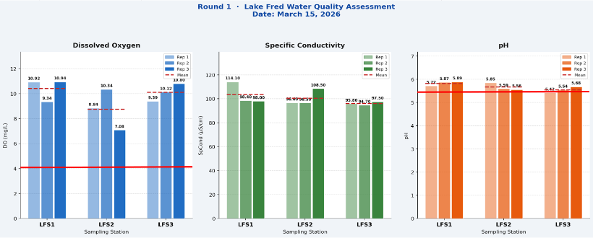
Graph 1. Bar Graph displaying Dissolved Oxygen, Specific Conductivity, and pH for each station for Round 1.

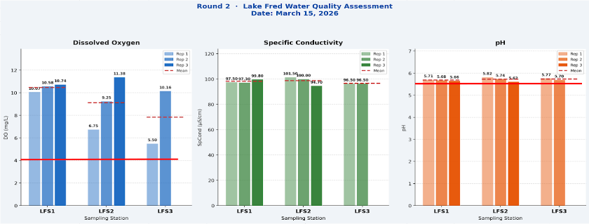
Graph 2. Bar Graph displaying Dissolved Oxygen, Specific Conductivity, and pH for each station for Round 2.

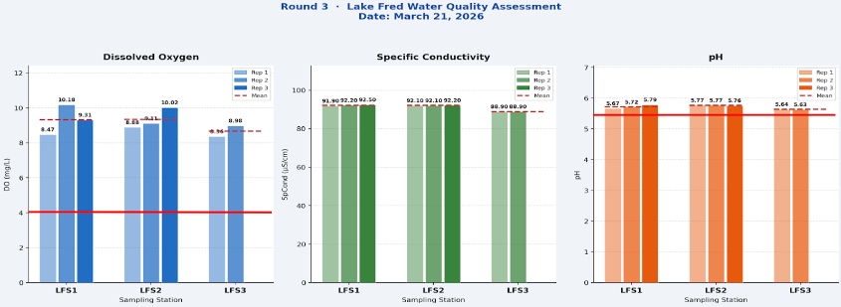
Graph 3. Bar Graph displaying Dissolved Oxygen, Specific Conductivity, and pH for each station for Round 3.

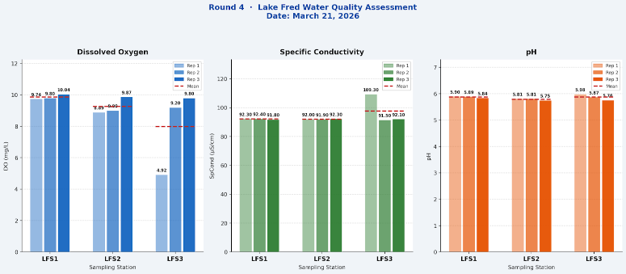
Graph 4. Bar Graph displaying Dissolved Oxygen, Specific Conductivity, and pH for each station for Round 4.
Across all four rounds and all three stations, specific conductivity and pH have minimal, often negligible, variations from the mean, with similar means across days and locations. DO, however, shows considerable variation from the mean throughout. Notably, LFS2 and LFS3 show significantly more variation than LFS1. LFS2 varies considerably during rounds 1 & 2, while LFS3 varies considerably during rounds 2 & 4. This suggests that Lake Fred might not be significantly stratified, despite being an artificial lake. The red solid line in each of these graphs indicate the legal limit of dissolved oxygen and pH, respectively. There is no reported statewide standard for Specific Conductivity in freshwater lakes.

Graph 5. Nitrate (NO₃⁻) Levels Throughout Sampling.
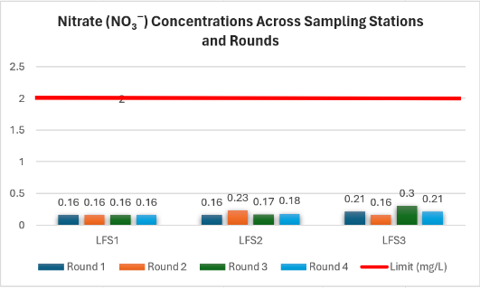
Graph 5 shows the concentrations of NO₃⁻ measured in Lake Fred throughout the duration of sampling, relative to the legally acceptable maximum values. All NO₃⁻ levels were determined to be well below this limit.
Graph 6. Total Phosphorus (TP) Levels Throughout Sampling.
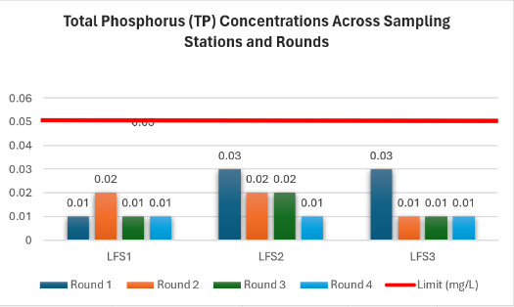
Graph 6 shows the concentrations of TP measured in Lake Fred throughout the duration of sampling, relative to the legally acceptable maximum values. All TP levels were determined to be safely below this limit.

Graph 7. Turbidity Levels Throughout Sampling.
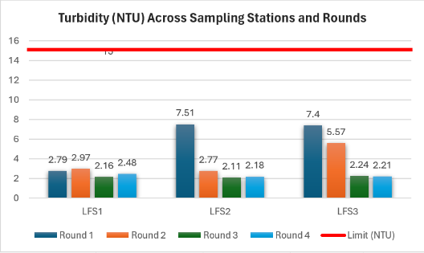
Graph 7 shows turbidity measurements across Lake Fred throughout the duration of sampling, relative to the acceptable maximum turbidity of 15 NTU. All turbidity values measured were determined to be significantly below this limit.
Graph 8. Temperature Measurements Throughout Sampling.
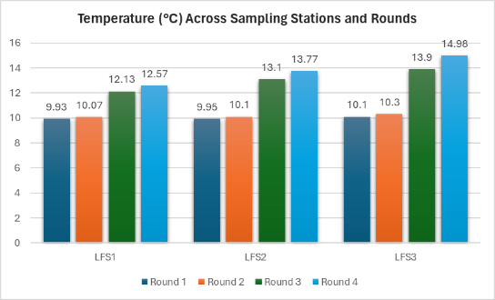
Graph 8 compares temperature variation throughout sampling. Temperature measurements remained consistent across stations, indicating minimal spatial variation. A slight increase in temperature was observed between rounds 2 & 3, likely reflecting seasonal warming between sampling days.
Regarding Tables 3c & 5c: Fluorescence readings may have been more consistent during rounds 3 & 4 than they were during rounds 1 & 2 because wind conditions on Mar. 21st were less severe than they were on Mar. 15th.
Regarding Table 6: There is a general trend of decreasing TN from round 1 to round 4 across all stations. NO₃⁻ concentrations were notably elevated at LFS3 during round 3, which stands out as significant relative to other station-round combinations. This warrants further investigation. TP values were generally low, with higher values in rounds 1 & 2 and lower values in rounds 3 & 4. TP values were exceedingly low. This could be explained by seasonal weather conditions expected in the month of March.
Key Findings & Observations
The datasets associated with rounds 1 & 2 show water quality parameters with high variations between minimum and maximum values. This could be a result of inclement weather conditions on that sampling day or by the environmental conditions of an artificial lake. The datasets associated with rounds 3 & 4 show uniform water quality parameters, which appears to support the possibility that variation across Rounds 1 & 2 were the result of inclement weather. Consistency in rounds 3 & 4 may alternatively result from early spring weather, or they may instead suggest that stratification across Lake Fred is insignificant.
Low pH levels across all stations and rounds (5.42–5.98) indicate consistently acidic conditions, well below the 6.5–8.5 range typical of healthy freshwater ecosystems. This may reflect the influence of organic-rich soils around the perimeter of Lake Fred. More testing is required.
Dissolved oxygen levels at LFS3 are lower during rounds 2 & 4 than at the LFS1 & LFS2 stations. The region at LFS3 is significantly more shallow and turbid, which may account for the decreased dissolved oxygen levels. In shallow artificial lakes (approximately 1.5 to 2 meters in depth), wind-driven wave action can result in frequent sediment resuspension, which elevates turbidity. This process can intensify over the season through internal nutrient loading and reduced macrophyte stabilization, leading to persistently turbid conditions (Li et al., 2016).
Elevated turbidity levels present at LFS2 and LFS3 during rounds 1 & 2 (which were recorded at up to 7.51 NTU at LFS2 and 7.40 NTU at LFS3), compared to calmer conditions in rounds 3 & 4 (all below 2.5 NTU), may be attributable to the high wind conditions recorded on March 15th. These high winds may have led to repeated sediment resuspension.
Phycocyanin fluorescence readings act as a proxy indicator for cyanobacteria (blue-green algae) presence. These readings were generally low across stations. However, they were notably high at LFS3 during round 1 (15 RFU) and at LFS2 during round 2 (12 RFU), suggesting minor cyanobacterial activity during these areas on the first sampling day.
Nutrient concentrations (TN and TP) declined across the four rounds. All values remained at levels associated with mesotrophic to eutrophic conditions for shallow lake systems (Limnology 101 | Understanding Trophic States, 2026).
One data point from round 4 at LFS3 was flagged as an outlier by the field team, as discussed in the “Value of Uncertainty” section. This could reflect instrument error or ambient air interference.
Data Quality Notes & Limitations
Several data quality issues were documented during and after field collection that may limit the interpretability of these preliminary results:
- Improper sample preparation: All nutrient samples (TN, NO₃⁻, & TP) were transported without adequate preservation. Confirmatory sampling with proper cold-chain preservation is required before any management conclusions can be drawn. This was not performed by the project team, which may have negatively impacted data integrity.
- Depth inconsistencies: Rounds 3 & 4 show inconsistencies in the depths measured by the YSI ProDSS. This was a result of improper calibration before water-parameter measurements were taken. Since the stations during these rounds report readings at 0.1 meters, but not during rounds 1 & 2, this means that the data set should be taken with caution for depth-profile analysis and future collection.
- Algal Biomass: The initial sampling plan did not integrate chlorophyll-a (algal biomass) as a water quality parameter to be collected in the scope of this project. Increased sample collection for further cyanotoxin laboratory analysis will provide future project teams with algal biomass data, which can then be compared against NJ monitoring networks to assess harmful algal blooms.
- Temporal limitability: The project team was hindered significantly by time and scheduling constraints, which limited the sample collection window to a maximum 3-week period. This was restricted even further to just two days.
- Temporal variability: Minor fluctuations in temperature and dissolved oxygen readings suggest that there was some diurnal variability during sampling days. This may also simply result from the fact that all samples were taken during daylight hours.

Recommended Next Steps
The project team would advise recollection of sampling data using YSI ProDSS equipment again, for a more accurate picture of the depth profile and reflective water-quality parameters. It is recommended for this to occur during a minimum 4-month window for a better understanding of water quality variation and nutrient fluctuation patterns across Lake Fred. Sampling schedules should be more structured to provide a consistent baseline. Future sampling should ideally occur throughout the year. Sampling schedules should be more structured to provide a consistent baseline. Sampling should follow proper sample preservation protocols to maximize data quality, such as transporting and storing samples on ice. Samples should be collected at different, consistently scheduled, times of the day and night for a more complete understanding of day-night parameter variability.
Future teams should examine the presence of low pH values across all monitoring stations, in connection with the soil chemistry across the perimeter of Lake Fred. Soil chemistry may account for high acidity during the spring time.
Once more complete data is available, Secchi disk readings and phycocyanin data readings should be integrated into nutrient result data to develop a Tropic State Index estimate for Lake Fred.
Conclusion
Lake Fred is a shallow artificial lake system where physical mixing and sediment resuspension strongly influence water quality conditions. Observed variability in water clarity between sampling events—specifically a transition from turbid to clearer conditions within 24 hours—suggests that suspended sediments, rather than algal biomass, were the primary driver of reduced transparency. Due to the absence of chlorophyll-a data and the limited temporal scope of sampling, trophic status was evaluated using a weight-of-evidence approach. While the total phosphorus conditions may indicate the potential for eutrophic conditions, the lack of persistent turbidity and the dynamic nature of the system limit definitive classification (Kowalczewska-Madura et al., 2024). Another observation of there being no reported total nitrogen limits across pineland lakes and only Nitrate standards in New Jersey, is likely to due the region naturally having low nitrate levels and the unique high sensitive ecology or the region, according to the Pinelands Comprehensive Management Plan (New Jersey Pinelands Commission | the Comprehensive Management Plan, retrieved 2026).
Disclaimer: All results presented in this report are preliminary and represent estimated values, due to sample preservation issues and limited data availability. Data presented are not suitable for regulatory submission, permit compliance, or formal water quality classification without confirmatory resampling under standard NJDEP protocols. This report is intended for internal project tracking and educational purposes only.
Literature Cited
Kowalczewska-Madura, K., Dunalska, J.A., Kutyla, S., & Kobus, S. (2024). Bottom sediments as an indicator of the restoration potential of lakes—a case study of a small, shallow lake under significant tourism pressure. Scientific Reports, 14(1), 13438. https://doi.org/10.1038/s41598-024-64058-9.
Li, Y., Tang, C., Wang, J., Acharya, K., Du, W., Gao, X., Luo, L., Li, H., Dai, S., Mercy, J., Yu, Z., & Pan, B. (2017). Effect of wave-current interactions on sediment resuspension in large shallow Lake Taihu, China. Environmental Science and Pollution Research, 24(4), 4029–4039. https://doi.org/10.1007/s11356-016-8165-0.
2023, December 18). N.J.A.C. 7:9B - Surface Water Quality Standards [Review of N.J.A.C. 7:9B - Surface Water Quality Standards]. https://dep.nj.gov/wp-content/uploads/rules/rules/njac7_9b.pdf
NJCOLA - Lake Water Quality Testing. (Retrieved April 2026). Njcola.org. https://njcola.org/Lake-Water-Quality-Testing
Limnology 101| Understanding Trophic States. (2026). Ysi.com. https://www.ysi.com/ysi-blog/water-blogged-blog/2023/09/limnology-101-understanding-trophic-states?srsltid=AfmBOoo4IvqKK2W_gTxlkpyMcgKBYtUt6mirR0KZ86O5d4Ho0UDU0N1p
NJDEP| Bureau of Freshwater and Biological Monitoring | Lake Monitoring. (2025, December 10). Bureau of Freshwater and Biological Monitoring. https://dep.nj.gov/wms/bfbm/lake-monitoring/#capabilities
New Jersey Pinelands Commission | The Comprehensive Management Plan. (n.d.). Www.nj.gov. https://www.nj.gov/pinelands/cmp/

Appendix A: Q-Test Calculations
The following are the calculations performed during the Q-Tests for the fourth dataset for Round 4 LFS3. All calculations were performed in Excel sheets. Q_{t} values were determined using n=18. Q_{90%}=0.313, Q_{95%}=0.356, Q_{99%}=0.442.
Temp: $Q_{c}=\frac{\left|18.1-13.9\right|}{18.1-12}=0.6885...$, Q_{c}>Q_{99%}.
Pressure: $Q_{c}=\frac{\left|757.9-757.8\right|}{758.2-757.6}=0.1666...$, Q_{c}<Q_{90%}. Notably, A≠L and A≠S, meaning that A could never have been an outlier.
DO SAT%: $Q_{c}=\frac{\left|99.3-95.6\right|}{99.3-47.6}=0.0716...$, Q_{c}<Q_{90%}.
DO (mg/L): $Q_{c}=\frac{\left|9.36-9.31\right|}{10.18-4.92}=0.0095...$, Q_{c}<Q_{90%}. Notably, A≠L and A≠S, meaning that A could never have been an outlier.
Spec. Con: $Q_{c}=\frac{\left|0.8-88.9\right|}{109.3-0.8}=0.8120...$, Q_{c}>Q_{99%}.
Salinity: $Q_{c}=\frac{\left|0-0.04\right|}{0.05-0}=0.8$, Q_{c}>Q_{99%}.
pH: $Q_{c}=\frac{\left|5.98-5.98\right|}{5.98-5.63}=0$, Q_{c}<Q_{90%}. Notably, A=C exactly, meaning that A could never have been an outlier.
Appendix B: Quote from the NJDEP QAPP
Sampling depth was determined based on the NJDEP Lakes Monitoring Network 2025 Quality Assurance Protection Plan (QAPP). The exact protocol for field and sample collection is highlighted below:
A total depth reading will be obtained to determine how the top-to-bottom profile will be collected at each in-lake station for optical dissolved oxygen (ODO), pH, chlorophyll a, phycocyanin, specific conductance, and water temperature and depth. Readings for these parameters will be collected as stated below.
- All stations require a reading at 0.1 meters below the surface and a determined sample depth.
- Stations with total depths ≤ 1.0 meter require readings at half of the total depth.
- Stations with total depths < 3.0 meters require readings at 0.5-meter intervals.
- Stations with total depths ≥ 3.0 meters require readings at 1.0-meter intervals to 20 meters.
After 20 meters, reading is required at 2.0-meter intervals.
Stations with total depths > 1.0 meters require a reading at 0.5 meters above the bottom.
Readings and sample depths will not necessarily be recorded at whole numbers due to the high accuracy (±0.004m for 10-meter cables and ±0.04m for 30-meter cables) of the depth sensor used.
Sample collection
Samples will be collected in accordance with NJDEP FSPM 2024. Samples will be collected using a horizontal submerged sampler, which will be cleaned at the BFBM laboratory prior to use at each lake (see previous section) . The submerged sampler will be field rinsed with "water of interest" once prior to collecting a sample at each station and/or depth for the lake. Each individual lake will require one clean submerged sampler.
Total depth, measured in the top-to-bottom profile described in the previous section, will determine sample depth at each station.
Samples will be collected from one (1) meter depth at stations ≥1.5 meters total depth.
Samples will be collected from mid-depth at stations <1.5 meters total depth.
The sample will be analyzed for the parameters listed in Appendix E, Lake Sampling Parameters according to the lake type. Turbidity will be measured from an aliquot of the grab sampled collected at required depth using a Hach 2100Q Turbidity meter.
Secchi Depth: Universal 20cm Secchi disc to measure water transparency. All lake monitoring stations require a Secchi depth measurement and shall be recorded following guidance below.
Secchi depth measurement <1.0-meter, record to the nearest 0.05 meter.
Secchi depth measurement >1.0-meter, record to the nearest 0.1 meter.
Forel-Ule Color: Forel-Ule Color Comparator. Forel-Ule Color is measured at half secchi depth. The measurement is for general information purposes and not used for the project data objectives.
Section of protocol rules taken from Project Name: Lake Monitoring Network Version Date: 5/21/2025, NJDEP QAPP #: FY25-31*

